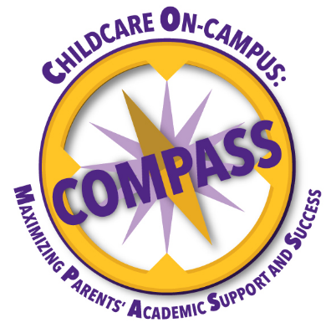
About COMPASS
The mission of COMPASS (Childcare on Campus: Maximizing Parents’ Academic Support and Success) is to provide affordable childcare on campus and other specialized wrap-around resources that support student-parents in achieving their academic goals.
The vision of COMPASS is to maximize retention of student-parents at East Carolina University.

COMPASS at ECU is funded by the U.S. Department of Education and provides childcare to ECU student parents through:
- Subsidized tuition at the Nancy W. Darden Child Development Center https://hhp.ecu.edu/hdfs/ndcdc/
- Drop off Childcare M-TH 6:00 pm-9:00 pm at the DOCC at Darden https://hhp.ecu.edu/hdfs/docc/
- Parenting Education and Specialized Advising

To qualify for COMPASS, you must be a full-time ECU student, currently pregnant or the parent of at least one child 18 years or younger, and meet one of the following:
- Pell grant recipient.
- A graduate student who's filed FAFSA demonstrates an expected family contribution below $6,200.

How to apply?
Apply for COMPASS here: COMPASS Application
Once you have completed the application, you will receive an email from COMPASS@ecu.edu with an eligibility letter and the services available!
COMPASS Parent Advisor: Brandi Harris harrisbr@ecu.edu
For more information about the DOCC at Darden evening childcare contact Brianna Webb webbb23@ecu.edu or click the link https://hhp.ecu.edu/hdfs/docc/

